Re-Wireable Male Inline Plug 32 Amps @ 250V - Commando (PWR-CMD-P3234)

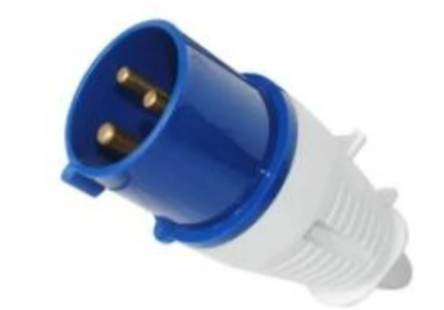

Description:
The LMS Power PWR-CMD-P3234 is a high quality, IP44 rated and completely
re-wireable 32 Amp Commando plug used for very high electrical load applications.
The standard design used for power generation, power distribution extensions and other appliances that need the larger 32 Amp conformance standard.
Quality build assured, 32 Amp rated nickel pole design together with a large cable entry cross-section.

Applications:
Create bespoke electrical connections electrical systems
Create electrical connections for very high power appliances
Needed when separate electrical circuits are required

Product Code:
Part Number: PWR-CMD-P3234
EAN: xxxxxxxxxx
Weight: 0.1Kg approx

Technical Specifications:
Warranty LMS Data 2-Year Warranty
Chassis Thermoplastic, screw down housing
Load 32 Amps 250 Volts (Nominal)
Poles/Hours 2P+E/6H
Standards CE Certified
Cable Entry 8mm-23mm (approx)

Supplied With:
PWR-CMD-P3234 Commando Plug
* Specifications and product design are subject to change. E&OE.

